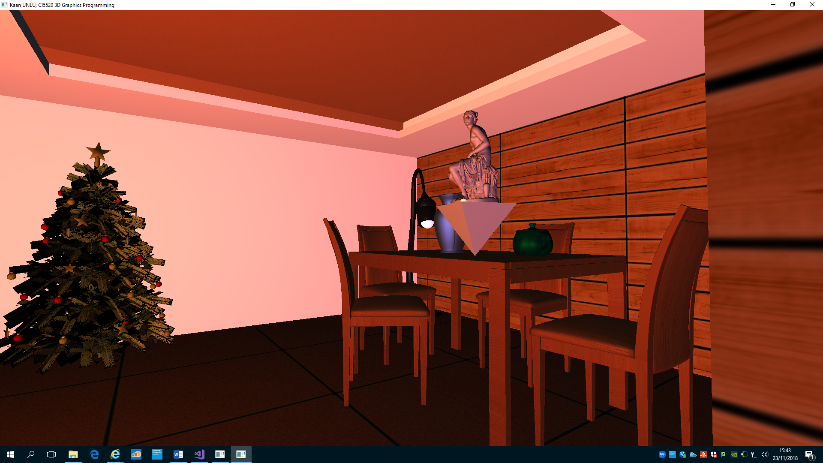Indoor Scene with Lighting

Over dim ambient light and also dim reddish directional light coming from the window, two lightbulbs provide point light. One of them sits in a lamp and gives bluish point light. The other; giving yellowish point light on the rotating pyramid, rotates with it and lights the marble statue at different angles as time passes. Both lights can be turned off and on at will and separately: Their bulbs look dark and they stop emitting light when they are turned off. Point light is set up on the fragment shader to provide more realistic lighting. Objects of different specularity and textures are scattered around the room in a logical order.

All in all, the scene resembles a kitchen at a Christmas morning; with a mystical present on the table waiting for whoever that might find it.